S501 Login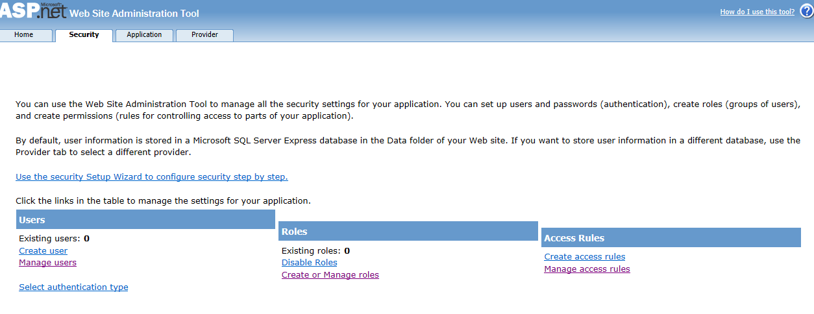

S502 Information Upload

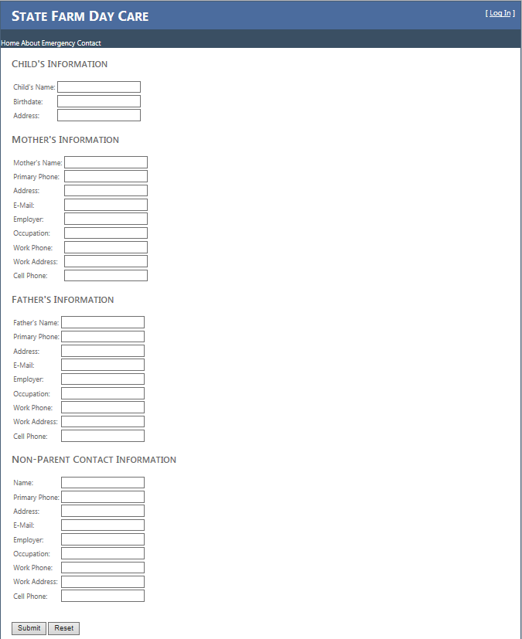

S503 Maintain User Accounts

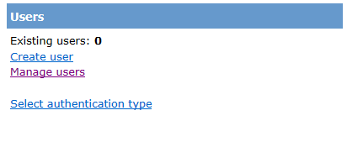

S504 Maintain ASP.NET Roles



S505 Role Functionality

